Accounting for sampling uncertainty in analyses of published projection matrices

Authors:
Patrick M. Barks*, Owen R. Jones

Affiliation:
Interdisciplinary Centre on Population Dynamics (CPop)
Department of Biology
University of Southern Denmark
5230 Odense M, Denmark

*Corresponding author:
Email: patrick.barks@gmail.com

Running title:
Sampling uncertainty in projection matrices

Abstract
- The collation of thousands of population projection matrices in the COM(P)ADRE Matrix Databases has facilitated large-scale comparative analyses in the fields of ecology, evolution, and demography. One potential limitation of most such analyses is that they don’t account for uncertainty in the transition rates that populate projection matrices (i.e. rates of survival, growth, and reproduction). These transition rates are almost always estimated based on samples from a population, but the corresponding sampling uncertainty is rarely reported, and often difficult to derive without additional data from the original authors.
- To understand whether sampling uncertainty is relevant for analyses of published projection matrices, we identified a subset of studies with projection matrices available in the COMPADRE Plant Matrix database and examined the papers or contacted authors to obtain estimates of sampling uncertainty for each transition rate, or the data necessary to model it (e.g. transition-specific sample sizes). We then conducted parallel analyses that either incorporated or ignored sampling uncertainty and compared the results.
- Our results were mixed. A comparative analysis relating to demographic senescence was moderately impacted by sampling uncertainty, whereas a within-species analysis of the effect of weather on reproductive rates was unaffected. Sampling uncertainty was a small component of the total variation in some parameters we examined (e.g. population growth rate), but a substantial component of others (e.g. shape of the mortality distribution). We also found that if sampling uncertainty is ignored, some parameters derived from projection matrices can be biased due to boundary-estimates of stage-specific survival (i.e. estimates approaching either 0% or 100%), which are common among published projection matrices.
- Incorporating sampling uncertainty into analyses of published projection matrices can lead to better inference, and a more rigorous accounting of uncertainty. Further progress in this area is primarily limited by data availability. We outline reporting guidelines for authors of projection matrices that will enable other researchers to more readily incorporate sampling uncertainty into their analyses.

1. Introduction
The collation of published demographic data in databases such as PanTHERIA (Jones et al. 2009), AnAge (de Magalhães and Costa 2009), Myhrvold et al.’s (2015) amniote life history database, and COM(P)ADRE (Salguero-Gómez et al. 2015, Salguero-Gómez et al. 2016a), has facilitated fascinating comparative analyses in the fields of ecology, evolution, and demography (e.g. Garratt et al. 2013, Adler et al. 2014, Healy et al. 2014, Fristoe et al. 2017). By leveraging open-source databases that combine data from hundreds of individual studies, researchers are able to test hypotheses of interest at taxonomic, spatial, and temporal scales that would not otherwise be possible. However, analyzing “other people’s data” also has its challenges.
One challenge in working with large collections of published data is that it can be difficult to understand and model sources of underlying uncertainty. For instance, the demographic parameters reported in the databases noted above have almost always been estimated from a sample of individuals from some larger population of interest, and therefore have inherent sampling uncertainty. However, parameter-specific sample sizes and standard errors are rarely available, and are often difficult to obtain even from the original data sources. These original studies, which produce the parameter estimates that are later compiled in demographic databases, almost always account for sampling uncertainty in their own analyses. However, studies that subsequently analyze parameter estimates compiled in demographic databases rarely account for uncertainty in those estimates — an omission that may lead to bias or overconfidence (Biggs et al. 2009).
Here we investigate sampling uncertainty in the COMPADRE Plant Matrix Database (Salguero-Gómez et al. 2015; www.compadre-db.org), which currently contains over 9,000 matrix population models (i.e. projection matrices, hereafter MPMs) collected from more than 650 studies. Over the course of its 20-year development, researchers have used COMPADRE (and the sister animal matrix database COMADRE; Salguero-Gómez et al. 2016a) to tackle diverse topics in ecology, evolution, and demography, including, for example, studies on the structuring of life history variation (Franco & Silvertown 1996, Salguero-Gómez et al. 2016b), comparative analyses of ageing (Baudisch et al. 2013, Jones et al. 2014), tests of the demographic buffering hypothesis (McDonald et al. 2017), and analyses of the impact of climate on population dynamics (Coutts et al. 2016, Csergő et al. 2017). In practice, all of these analyses involve deriving parameters from a set of MPMs in COMPADRE (e.g. the equilibrium population growth rate λ, elasticities of λ, reproductive values, mean vital rates, generation time, life expectancy, etc.), and then incorporating these parameter estimates, or further derivations, into a statistical model. Our focus here is on the uncertainty in such parameter estimates due to sampling uncertainty in the transition rates that populate each MPM — estimated rates of survival, growth, and reproduction. Though sample sizes are not reported in COMPADRE, anecdotally we know that some transition rates within some of the MPMs have been estimated from small samples — as small as a single individual in a few cases. Our goals here are to illustrate how sampling uncertainty in transition rates propagates to the parameters that researchers are ultimately interested in, and to probe the extent to which sampling uncertainty in MPMs may be relevant for analyses with COMPADRE.

2. Methods
2.1 Background on the COMPADRE Plant Matrix Database
The COMPADRE database includes MPMs and associated metadata from published studies dating as far back as 1966 (Salguero-Gómez et al. 2015). Where possible, MPMs are split into component processes of survival, growth, and retrogression (the U matrix), sexual reproduction (F), and clonal reproduction (C). The database includes a variety of metadata associated with each MPM, including the relevant time period, geographic coordinates of the study site, population or site identifiers, and treatment conditions. From a given source study, COMPADRE often contains multiple MPMs reflecting different sites, time periods, and/or treatment conditions, as well as one or more “mean MPM” calculated as an element-by-element arithmetic mean over multiple years and/or sites.

2.2 Target studies
We used a pre-release version of the COMPADRE database (compiled 2017-11-22) to identify an initial group of 91 studies that we sought to obtain data for. The initial search criteria were: studies published between 2010–2017, species of common perennial growth types (herbaceous, shrub, tree, palm, and succulent), wild populations not subject to any experimental treatment, and MPMs with three or more stage classes and a projection interval of one year. Of the 91 studies that met our initial criteria, we were able to obtain data necessary to model sampling uncertainty for 28, representing a total of 298 MPMs for 73 populations of 27 species. We supplemented this set with 5 additional studies published prior to 2010, that we had previously obtained data for (these had previously been targeted based on a criterion of ≥4 years of temporal replication). Our final set therefore included 33 studies, representing 325 MPMs for 82 populations of 32 species.

2.3 Typical construction of matrix population models
A matrix population model $A$ is a square projection matrix whose elements $A_{ij}$ represent estimated transition rates from stage class j to stage class i over one projection interval (typically one year). Transitions may reflect the passage of individuals from one stage to another based on survival, growth, or retrogression (the U component), or the production of new individuals via reproduction (the F component); $A=U+F$. Sometimes the reproductive transitions are further split into sexual and clonal contributions.
The methodology used to estimate transition rates varies among studies, but in general, survival-related transitions are estimated directly from observed transition frequencies within a sample of tagged individuals, as in
$$U_{ij}\left(t\right)=\frac{number transitioned from stage j in year t-1 to stage i in year t}{number in stage j in year t-1}.$$
Reproductive transitions are sometimes estimated directly from counts of new recruits at time t per reproductive individual at time t-1, as in
$$F_{sr}(t)=\frac{number in recruit stage s in year t }{number in reproductive stage r in year t-1}.$$
Alternatively, reproductive transitions may be split into multiple lower-level vital rates (e.g. numbers of flowers per plant, fruits per flower, and seeds per fruit, seed survival probability, and seed germination probability), which are typically estimated from separate samples, and then multiplied to derive the overall transition rate. In some studies, transition rates are estimated using more nuanced statistical models, that partially-pool estimates across stage classes, sites, and/or years, or incorporate additional variables external to the MPM.

2.4 Sampling distribution for a single MPM
Techniques for estimating sampling uncertainty in transition rates and derived parameters are reviewed in Caswell (2001, Ch. 12). The method we use here is parametric bootstrapping, in which we generate a sampling distribution for each MPM by taking 2,000 independent random draws from the sampling distribution of each underlying transition rate. For example, if $U_{ij}$ is a survival-related transition from stage j to i, estimated based on the observation that $k$ out of the $n$ individuals in stage j survived and transitioned to stage i (and the remaining $n-k$ died), we can model the $U_{ij}$ transition as a binomial sample with k successes in n trials. We could equivalently use a multinomial likelihood here (given observed counts $x_{m}$ of each possible outcome $m$), which has the advantage of flexibly scaling to instances with more than two possible outcomes (e.g. an individual from stage j might die, survive and remain in stage j, or survive and grow to stage j+1). For reproductive transitions, we use a Poisson likelihood to model the number of recruits k produced by a given number of reproductive individuals n.
We illustrate with an MPM for the perennial forb Agrimonia eupatoria (Rosaceae) from a study carried out in southern Sweden (Kiviniemi 2002) (Population ‘B’; projection interval 1997-1998),
$$A=\left(\begin{matrix} & & & F_{14} \\ U_{21} & U_{22} & & \\ & U_{32} & U_{33} & U_{34} \\ & & U_{43} & U_{44}\end{matrix}\right)=\left(\begin{matrix} & & & 0.19 \\ 0.86 & 0.78 & & \\ & 0.06 & 0.67 & 0.28 \\ & & 0.22 & 0.70\end{matrix}\right).$$
In that study, ~80 plants were monitored each year in a population estimated to contain ~1000 individuals. The raw transition frequencies used to derive the focal MPM (including death transitions $U_{dj}$ appended as an extra row) were
$$\left(\begin{matrix} & & & F_{14} \\ U_{21} & U_{22} & & \\ & U_{32} & U_{33} & U_{34} \\ & & U_{43} & U_{44} \\ U_{d1} & U_{d2} & U_{d3} & U_{d4}\end{matrix}\right)=\left(\begin{matrix} & & & 9/47 \\ 12/14 & 14/18 & & \\ & 1/18 & 6/9 & 13/47 \\ & & 2/9 & 33/47 \\ 2/14 & 3/18 & 1/9 & 1/47\end{matrix}\right).$$
Given these transition frequencies, the sampling distributions of the underlying transition rates correspond to the following models:
$$\left(12, 2\right) \sim Multinomial\left(\left(U_{21}, U_{d1}\right)\right),$$
$$\left(14, 1, 3\right) \sim Multinomial\left(\left(U_{22},U_{32}, U_{d2}\right)\right),$$
$$\left(6, 2, 1\right) \sim Multinomial\left(\left(U_{33},U_{43}, U_{d3}\right)\right),$$
$$\left(13, 33, 1\right) \sim Multinomial\left(\left(U_{34},U_{44}, U_{d4}\right)\right),$$
$$9 \sim Poisson\left(exp\left(F_{14}+log\left(47\right)\right)\right).$$
To create a sampling distribution for the focal MPM, we take 2,000 independent draws from the sampling distributions implied above (see section 2 of Appendix S1 for a more complete description of this methodology). At each iteration, we arrange the drawn transition rates into the form of our MPM and then use that MPM draw to calculate our derived parameter(s) of interest. After 2,000 iterations, we therefore have 2,000 independent draws from the sampling distribution of each transition rate and derived parameter.
The modest sample sizes underlying this particular MPM (9-47 plants per stage class) lead to relatively high sampling uncertainty in the transition rates (Fig. 1A). For instance, the sample estimate for the vegetative-reproductive growth transition is 0.22 (2/9), but based on the upper bound of the 95% credible interval, this transition rate could plausibly have been as high as 0.45 in the population at large. Correspondingly, there is substantial sampling uncertainty in some of the derived parameters (Fig. 1B). Based on 95% credible interval bounds, the equilibrium population growth rate could be as low as –17% per year or as high as +1% per year, life expectancy could be just 3.5 years or up to 18.2 years, and the reproductive value of the vegetative stage class could be 22% lower than the seedling stage or 1460% higher.

2.5 Case Study #1: Comparative analysis of mortality trajectories
The analysis we focus on here is a test of the relationship between mature life expectancy and the “shape” of the mortality distribution (sensu. Baudisch 2011), where shape indicates how sharply mortality rates increase with age following reproductive maturity. Evolutionary biologists have long been interested in understanding variation in mortality trajectories in the context of evolutionary theories on senescence, but previous metrics used to compare rates of senescence may have conflated variation in the shape of mortality trajectories and variation in the average level of mortality (i.e. the inverse of life expectancy). Measures of shape proposed by Baudisch and colleagues (Baudisch 2011, Baudisch et al. 2013, Wrycza et al. 2015) are mathematically independent of life expectancy, and therefore well-suited for comparative analyses. Whether shape is biologically independent of life expectancy is a separate question, and indeed an analysis by Baudisch at al. (2013) (based on MPMs for 290 angiosperm species) found a positive relationship between life expectancy and the shape of mortality trajectories. Apart from that analysis, a number of other studies have used estimates of life expectancy and shape derived from MPMs in COM(P)ADRE, primarily in studies of life history variation (e.g. Salguero-Gómez et al. 2016, Healy et al. 2019).
To estimate mature life expectancy ($L$) and shape ($S$), we first used age-from-stage methods (Cochran and Ellner 1992, Caswell 2001 Sec. 5.3) to derive a survivorship trajectory from each MPM, using the first stage class(es) with positive reproduction as our starting point (see Appendix S1 section 4 for further details). We then estimated mature life expectancy by summing over a given survivorship trajectory, as in $L=\sum_{x}{l_{x}}$, where $l_{x}$ is the proportion of a cohort surviving from reproductive maturity to age x. To estimate shape we used a metric proposed by Baudisch and Stott (2019), which compares the area under a survivorship trajectory to the area under a reference trajectory that assumes constant mortality with age. The metric can take any continuous value between –0.5 (maximal negative senescence; all individuals die at the age of maturity) and +0.5 (maximal senescence; all individuals die at the age of maximum longevity), with a value of 0 indicating a constant rate of mortality with age (negligible senescence). Values of shape that are greater than, equal to, or less than zero correspond to Type I, II, and III survivorship curves, respectively. When deriving a survivorship trajectory from an MPM, it is guaranteed that the apparent mortality rate will approach a plateau as the stage distribution approaches its equilibrium (Horvitz and Tuljapurkar 2008). To avoid bias from artifactual mortality plateaus, we calculated shape from truncated survivorship trajectories, limited to the period prior to a cohort reaching its quasi-stable distribution (based on a distance threshold of 1%; see Appendix S1 section 4 for further details).
We calculated life expectancy and shape at the level of populations, as defined in COMPADRE. For populations with temporal replication (i.e. MPMs for multiple time periods), we used the population pooled MPM in our analysis, if available, or the population mean MPM otherwise. To model sampling uncertainty for pooled or mean MPMs, we pooled stage-specific sample sizes across years (see further details in Appendix S1). This approach ignores potential uncertainty due to temporal variation in transition rates, and therefore underestimates overall uncertainty.
To model the relationship between point estimates of mature life expectancy and shape, we used a linear model with random intercepts at the species level (to control for non-independence of populations of the same species), as in
$$y_{ij} \sim Normal\left(α_{j}+βx_{ij},{ σ}^{2}\right),$$
where $x_{ij}$ and $y_{ij}$ represent point estimates of life expectancy and shape, respectively, for population i and species j, $α_{j}$ represent species-specific intercepts, $β$ is the slope of the relationship between S and L, and $σ^{2}$ is residual variance. To incorporate sampling uncertainty, we used a measurement error model (based on McElreath 2016, sec. 14.1.2) where $x_{ij}$ and $y_{ij}$ are modeled based on the means (${\hat{x}}_{ij}$ and ${\hat{y}}_{ij}$) and variances ( σx,ij2 and ${ \hat{σ}}_{y,ij}^{2}$) of their respective sampling distributions (derived as described in 2.4), as in
$$y_{ij} \sim Normal\left(α_{j}+βx_{ij},{ σ}^{2}\right),$$
$${\hat{x}}_{ij} \sim Normal\left(x_{ij}, { \hat{σ}}_{x,ij}^{2}\right),$$
$${\hat{y}}_{ij} \sim Normal\left(y_{ij}, { \hat{σ}}_{y,ij}^{2}\right).$$
We fit the above-described models using RStan (Stan Development Team 2018), with priors and settings as described in Appendix S2.
In supplementary analyses, we also estimated the variance components of life expectancy, shape, and other life history traits, focusing on the fraction of total variation attributable to transition-rate sampling uncertainty (further details in Appendix S1).

2.6 Case Study #2: The impact of weather on demographic traits
Here we examine how sampling uncertainty may affect inference regarding the effect of weather on demographic traits. We chose this topic because of its obvious significance to emerging research lines focusing on the impact of global climate change on both plant and animal demography. We focus on a 12-year MPM time-series for Silene spaldingii (Lesica and Crone 2007), a perennial herb found in semi-arid grasslands of western North America. In that study, transition rates were estimated using the methods described in 2.3 (i.e. as ratios of two integers), and corresponding stage-specific sample sizes are reported in Ellis et al. (2012). Eight of the MPMs within the 12-year time-series were non-ergodic due to missing estimates for the “rosette” stage class (i.e. because no rosettes were observed within the sample plots), so instead of examining variation in population growth rates (which assumes ergodicity), we focus only on the reproductive transition (hereafter ‘recruitment’, the number of seedlings in year t per reproductive plant in year t-1).
We examined the effect of monthly temperature deviations on annual recruitment using a similar approach to Teller et al. (2016), where we model separate slope coefficients for a series of K monthly lags (i.e. going back in time from the end of a given transition interval) in a way that allows for ‘smoothing’ of coefficients from nearby lags. The smoothing model we use here is a Gaussian process with an exponential covariance function, as in

$log(y_{t}) \sim Normal(α+\sum_{k}{b_{k}x_{tk},}{ σ}^{2})$ likelihood
$b \sim MVN(μ_{b}, Σ)$ climate coefficient for each monthly lag k
$Σ_{i,j}=η^{2}e^{-0.5ρ^{2}{(j-i)}^{2}}$ covariance matrix (row i, column j)

where $y_{t}$ is annual recruitment in year t, and $x_{tk}$ is the temperature deviation for year t at monthly lag k. Model parameters include the intercept ($α$), residual variance ($σ^{2}$), vector of monthly temperature coefficients ($b$), mean of the distribution of $b$ ($μ_{b}$), $K×K$ covariance matrix ($Σ$), maximum covariance for the $b$ distribution ($η^{2}$), and rate of decay in covariance with time ($ρ^{2}$).
In the model above, $y_{t}$ represents a point estimate of annual recruitment taken from the relevant MPM. Recall that these values were initially calculated as the number of seedlings in year t divided by the number of reproductive adults in year t-1. To incorporate sampling uncertainty into our model, we model the raw counts underlying the recruitment point estimates using a Poisson distribution, as in

$Y_{t} \sim Poisson(\exp\left(α_{t}+\sum_{k}{b_{k}x_{tk}}\right))$ likelihood
$α_{t} \sim Normal(μ_{α}+log⁡(N_{t-1}), { σ}_{α}^{2})$ year-specific intercepts
$b \sim MVN(μ_{b}, Σ)$ climate coefficient for each monthly lag k
$Σ_{i,j}=η^{2}e^{-0.5ρ^{2}{(j-i)}^{2}}$ covariance matrix (row i, column j)

where the response variable $Y_{t}$ is the number of seedlings in year t, and $N_{t-1}$ is the sample size of reproductive adults in year t-1. The model is otherwise similar to the model for point estimates, except that we use year-specific intercepts ($α_{t}$) to incorporate the Poisson offset ($N_{t-1}$), rather than a single model intercept as before. We fit the above-described models again using RStan, with priors and settings as described in Appendix S2.

3. Results
3.1 Comparative analysis of mortality trajectories
For our parameters of interest, life expectancy and shape, the estimated fractions of total variation attributable to sampling uncertainty were 10% and 47%, respectively (Table 1). Point estimates of life expectancy and shape were often shifted from their respective sampling distributions (Fig. 2). For shape, the most extreme positive and negative point estimates tended to have sampling distributions shifted much closer to zero, whereas for mature life expectancy, many point estimates were skewed upward from the median of the sampling distribution. The mismatches between point estimates and sampling distributions usually coincided with a boundary-estimate of stage-specific survival (i.e. a point estimate approaching either 0% or 100%). Supplementary analyses suggest that these boundary estimates can skew a point estimate for life expectancy or shape away from the majority of its sampling distribution (see section 5 of Appendix S1).
Despite the mismatch between point estimates and sampling distributions, accounting for sampling uncertainty in our test of the relationship between life expectancy and shape only moderately affected the overall result (Fig. 3). With respect to the slope parameter β, the posterior distribution from the point estimate model was centered slightly to the left of zero (P[β > 0] = 0.37), whereas the corresponding posterior from the sampling uncertainty model was shifted somewhat to the right (P[β > 0] = 0.75) (Fig. 3B), indicating stronger evidence for a positive relationship between life expectancy and shape. Counterintuitively, there was actually less posterior uncertainty in β in the sampling uncertainty model than the point estimate model, because the sampling distributions were more tightly clustered than the point estimates.

3.2 Case Study #2: The impact of weather on demographic traits
Despite the relatively small sample sizes underlying some estimates of recruitment (the three smallest sample sizes of reproductive individuals were 8, 12, and 13, respectively), results from the point estimate model and the sampling uncertainty model were virtually identical (Fig. 4A). Both identified temperature deviations in monthly lags 7-9 (February-April prior to the start of the transition interval in July) as having a positive effect on recruitment. If we simplify our model and just consider the relationship between recruitment and mean Spring temperature deviations (see full model specification in Appendix S1), we find that again the model of point estimates is similar to the model incorporating sampling uncertainty (Fig. 4B). The estimate of the temperature coefficient $β$ was about 5% higher, and the variance of that estimate about 10% higher, in the model incorporating sampling uncertainty compared to the model of point estimates. A difference of this magnitude is unlikely to qualitatively change any inferences drawn from a model.

4. Discussion
4.1 The impact of transition-rate sampling uncertainty on analyses of published MPMs
Sampling uncertainty in the transition rates underlying MPMs can, in principle, lead to substantial uncertainty in the parameters that researchers derive from MPMs, and which they are ultimately interested in. However, such uncertainty may not meaningfully impact the inferences drawn from any given analysis of published MPMs, if the number of MPMs or magnitude of the effect are large relative to the degree of within-MPM sampling uncertainty. In our study, accounting for transition-rate sampling uncertainty moderately affected the results of a comparative analysis relating to mortality trajectories, but had little impact on a within-species analysis of the effect of weather on demographic traits. Our analysis cannot definitively determine whether any other analysis of published MPMs will suffer from bias or overconfidence if transition-rate sampling uncertainty is ignored, but does highlight some critical issues that researchers should be aware of.
Perhaps the most significant issue highlighted by our analysis was that transition-rate sampling uncertainty may be a substantial component of the total variation in some MPM-derived parameters. In other words, for some parameters, much of the variation observed among published MPMs is not distinguishable from statistical noise. In our analysis, the most-affected parameter was the shape of the mortality distribution, for which almost half of the total variation was due to sampling uncertainty. We don’t know exactly why this particular parameter was so strongly affected. It could be that stage-structured MPMs are simply too coarse an instrument to yield reliable information about age-trajectories of mortality — particularly if we want to start from reproductive maturity (i.e. the starting point most relevant to evolutionary theory on senescence). For example, among the species-averaged MPMs in COMPADRE, 35% have been parameterized with a single reproductive stage class, meaning they yield no information about age-related variation among individuals that achieve and then remain in the reproductive class until death. Among MPMs with two or more reproductive stage classes, 28% have a time to quasi-stable distribution that’s less than one life expectancy, meaning that we only have reliable mortality estimates for relatively young age classes. We do not mean to suggest that researchers should never derive metrics like shape from stage-structured MPMs, but caution may be warranted in such analyses.
Another issue highlighted by our analysis was that some MPM-derived parameters are sensitive to boundary estimates of stage-specific survival (i.e. point estimates approaching either 0% or 100%). For instance, if an MPM has a stage-specific survival rate for which the point estimate is 100%, the resulting point estimate for life expectancy will likely be skewed upward from the median of the sampling distribution. If two or more stage classes have a survival estimate of 100%, this skew can be extreme. Estimating the frequency of rare events is notoriously difficult (Bailey 1997), and estimating the corresponding uncertainty is no easier. Empirical bootstrapping (Caswell 2001, sec. 12.1), a technique commonly used to estimate sampling uncertainty in demographic studies, is poorly suited for analyzing boundary estimates, because any bootstrap subsample from a group of individuals that all experienced the same outcome will always yield the exact same estimate. On the other hand, the particular approach to parametric bootstrapping used in the current study is not necessarily optimal for MPMs parameterized with multiple adult stage classes, for which it may be possible to ‘borrow strength’ across stages to improve statistical inference. In any case, survival estimates of 100% are relatively common among published MPMs (they occur in 24% of the species-averaged MPMs in COMPADRE; though only 7% of species-averaged MPMs in the animal database COMADRE), so researchers should be aware that some MPM-derived parameters might be sensitive to such estimates.
It’s important to note that our analysis of sampling uncertainty is separate from the issue of demographic stochasticity (these two phenomena are sometimes conflated, Kendall 1998), which occurs when individuals at a given stage and time exhibit variation in demographic rates. In the current study, we assume that the parameter of interest is in fact the population mean of a given trait (e.g. mean transition rate for a given stage class), and are only interested in sampling uncertainty in that specific parameter. However, independent of our uncertainty about the population mean, there is also likely to be individual-level variation around the population mean in the trait of interest (i.e. demographic stochasticity). Both phenomena — demographic stochasticity and sampling uncertainty — can have important implications for some types of analyses. For instance, in population viability analyses, failing to account for demographic stochasticity and sampling uncertainty will generally result in biased estimates of extinction risk (Kendall and Fox 2002, McGowan et al. 2011).

4.2 Accounting for sampling uncertainty
Incorporating transition-rate sampling uncertainty into analyses of published MPMs is challenging for two reasons. First, the requisite data are rarely reported. Of the 91 source publications that we initially targeted (all published between 2010-2017), only XX included the data necessary to model sampling uncertainty in survival-related transitions, and only XX included the data necessary to model uncertainty in reproductive transitions. To enable other researchers to understand and model sampling uncertainty associated with a published MPM, we recommend that authors of MPMs report the sample size and/or standard error associated with every reported transition rate (or lower-level vital rate, where applicable). For estimates derived from linear models, we recommend that authors include standard errors on the scale of the linear predictor (e.g. logit or log), to enable others to derive sampling distributions within the range of support (i.e. probabilities between 0 and 1, and rates greater than or equal to 0). We give more detailed reporting recommendations in Appendix S1.
The second challenge to incorporating transition-rate sampling uncertainty into analyses of published MPMs is the additional modeling effort required. Analyses of published MPMs may draw data from hundreds of studies (COMPADRE currently contains MPMs from 616 unique studies). Even if all those studies reported all underlying data, the effort required to collect that data and model sampling uncertainty for that many studies would be enormous. Further, there’s rarely a single ‘correct' approach to modeling transition rates. For instance, if demographic data are collected from multiple sites over multiple years, should we pool data across sites and years, or partially pool using a hierarchical model? In the latter case, should the factors be crossed or nested? For count data underlying reproductive transitions, should we use Poisson or negative binomial distributions? Such decisions should be informed by the specifics of each study, which makes this type of analysis difficult to apply at scale. That said, the lack of a single, perfect approach shouldn’t deter us from taking steps toward a more rigorous accounting of uncertainty.

4.3 Conclusions
Given that transition-rate sampling uncertainty was a small component of the total variation in many of the MPM-derived parameters we examined, we speculate that, for many analyses of published MPMs, accounting for sampling uncertainty would not qualitatively change the main results. However, some parameters that we examined, including life expectancy and the shape of the mortality distribution, were more strongly affected by sampling uncertainty. Of course, our analysis only examined a small number of MPM-derived parameters, based on a small fraction of the published MPMs available in one particular database. We therefore encourage more research in this area.
The increasing availability of large, compiled datasets in ecology and evolution brings new opportunities, but also new challenges. The data that end up in compiled databases have always been collected for a particular purpose — a purpose that will have informed the sampling design and statistical methodology used to generate that data. Among the hundreds of data sources underlying a given database, such as COMPADRE, there can be large variation not only in the degree of sampling uncertainty associated with parameter estimates, as we have examined here, but also in the broader assumptions and context in which the data were collected. Identifying and accounting for these sources of uncertainty is challenging, and generally requires better data reporting in primary sources, but can ultimately lead to more rigorous inferences.

Acknowledgements
We are indebted to the COMPADRE data digitization team and management committee for their work in developing the COMPADRE Plant Matrix Database. We thank X for providing information on sample sizes in their studies. This work was supported by a grant from the Independent Research Fund Denmark (grant 6108-00467B).

Author Contributions
P.M.B. and O.R.J. developed the idea for the study, P.M.B. performed the data collection and analyses, and P.M.B. wrote the manuscript with feedback and editing from O.R.J.

Data Accessibility
Data and R scripts required to reproduce our analyses are available at github.com/patrickbarks/mpm-uncertainty, and archived at the Dryad Digital Repository ([will insert citation if accepted]).

References
Adler, P. B., Salguero-Gómez, R., Compagnoni, A., Hsu, J. S., Ray-Mukherjee, J., Mbeau-Ache, C., and Franco, M. (2014) Functional traits explain variation in plant life history strategies. Proceedings of the National Academy of Sciences, 111, 740-745.
Bailey, R. T. (1997) Estimation from zero-failure data. Risk Analysis, 17, 375-380.
Baudisch, A. (2011) The pace and shape of ageing. Methods in Ecology and Evolution, 2, 375-382.
Baudisch, A., Salguero-Gómez, R., Jones, O. R., Wrycza, T., Mbeau-Ache, C., Franco, M., and Colchero, F. (2013) The pace and shape of senescence in angiosperms. Journal of Ecology, 101, 596-606.
Biggs, R., Carpenter, S. R., and Brock, W. A. (2009) Spurious certainty: how ignoring measurement error and environmental heterogeneity may contribute to environmental controversies. BioScience, 59, 65-76.
Caswell, H. (2001) Matrix population models: construction, analysis, and interpretation, 2nd ed. Sinauer, Sunderland, MA.
Cochran, M. E., and Ellner, S. (1992) Simple Methods for Calculating Age-Based Life History Parameters for Stage-Structured Populations. Ecological Monographs, 62, 345-364.
Coutts, S. R., Salguero-Gómez, R., Csergő, A. M., and Buckley, Y. M. (2016) Extrapolating demography with climate, proximity and phylogeny: approach with caution. Ecology Letters, 19, 1429-1438.
Csergő, A. M., Salguero-Gómez, R., Broennimann, O., Coutts, S. R., Guisan, A., Angert, A. L., Welk, E., Stott, I., Enquist, B. J., McGill, B., Svenning, J. C., Violle, C., and Buckley, Y. M. (2017) Less favourable climates constrain demographic strategies in plants. Ecology Letters, 20, 969-980.
de Magalhaes, J. P., and Costa, J. (2009) A database of vertebrate longevity records and their relation to other life-history traits. Journal of Evolutionary Biology, 22, 1770-1774.
Ellis, M. M., Williams, J. L., Lesica, P., Bell, T. J., Bierzychudek, P., Bowles, M., Crone, E. E., Doak, D. F., Ehrlén, J., Ellis-Adam, A., McEachern, K., Ganesan, R., Latham, P., Luijten, S., Kaye, T. N., Knight, T. M., Menges, E. S., Morris, W. F., den Nijs, H., Oostermeijer, G., Quintana-Ascencio. P. F., Shelly, J. S., Stanley, A., Thorpe, A., Ticktin, T., Valverde, T., Weekley, C. W. (2012) Matrix population models from 20 studies of perennial plant populations. Ecology, 93, 951-951.
Franco, M., and Silvertown, J. (1996) Life history variation in plants: an exploration of the fast-slow continuum hypothesis. Philosophical Transactions of the Royal Society of London B, 351, 1341-1348.
Fristoe, T. S., Iwaniuk, A. N., and Botero, C. A. (2017) Big brains stabilize populations and facilitate colonization of variable habitats in birds. Nature Ecology & Evolution, 1, 1706.
Garratt, M., Gaillard, J.-M., Brooks, R. C., and Lemaître, J.-F. (2013) Diversification of the eutherian placenta is associated with changes in the pace of life. Proceedings of the National Academy of Sciences, 110, 7760-7765.
Healy, K., Guillerme, T., Finlay, S., Kane, A., Kelly, S. B. A., McClean, D., Kelly, D. J., Donohue, I., Jackson, A. L., and Cooper, N. (2014) Ecology and mode-of-life explain lifespan variation in birds and mammals. Proceedings of the Royal Society B: Biological Sciences, 281, 20140298.
Healy et al. (in review) Beyond the fast-slow continuum in animal life-histories. Nature Ecology and Evolution.
Horvitz, C. C., and Tuljapurkar, S. (2008) Stage dynamics, period survival, and mortality plateaus. The American Naturalist, 172, 203-215.
Jones, K. E., Bielby, J., Cardillo, M., Fritz, S. A., O'Dell, J., Orme, C. D. L., Safi, K., Sechrest, W. Boakes, E. H., Carbone, C., Connolly, C., Cutts, M. J., Foster, J. K., Grenyer, R., Habib, M., Plaster, C. A., Price, S. A., Rigby, E. A., Rist, J., Teacher, A., Bininda-Emonds, O. R. P., Gittleman, J. L., Mace, G. M., and Purvis, A. (2009) PanTHERIA: a species-level database of life history, ecology, and geography of extant and recently extinct mammals. Ecology, 90, 2648-2648.
Jones, O. R., Scheuerlein, A., Salguero-Gómez, R., Camarda, C. G., Schaible, R., Casper, B. B., Dahlgren, J. P., Ehrlén, J., García, M. B., Menges, E. S., Quintana-Ascencio, P. F., Caswell, H., Baudisch, A., and Vaupel, J. W. (2014) Diversity of ageing across the tree of life. Nature, 505, 169-173.
Kendall, B. E. (1998) Estimating the magnitude of environmental stochasticity in survivorship data. Ecological Applications, 8, 184-193.
Kendall, B. E., and Fox, G. A. (2002) Variation among individuals and reduced demographic stochasticity. Conservation Biology, 16, 109-116.
Kiviniemi, K. (2002) Population dynamics of Agrimonia eupatoria and Geum rivale, two perennial grassland species. Plant Ecology, 159, 153-169.
Lesica, P., and Crone, E. E. (2007) Causes and consequences of prolonged dormancy for an iteroparous geophyte, Silene spaldingii. Journal of Ecology, 95, 1360-1369.
McDonald, J. L., Franco, M., Townley, S., Ezard, T. H., Jelbert, K., and Hodgson, D. J. (2017) Divergent demographic strategies of plants in variable environments. Nature Ecology & Evolution, 1, 0029.
McElreath, R. (2018) Statistical Rethinking: A Bayesian course with examples in R and Stan. Chapman and Hall/CRC.
McGowan, C. P., Runge, M. C., and Larson, M. A. (2011). Incorporating parametric uncertainty into population viability analysis models. Biological Conservation, 144, 1400-1408.
Myhrvold, N. P., Baldridge, E., Chan, B., Sivam, D., Freeman, D. L., & Ernest, S. M. (2015) An amniote life-history database to perform comparative analyses with birds, mammals, and reptiles. Ecology, 96, 3109-3109.
Peng, R. D. (2018) Context Compatibility in Data Analysis [Blog Post]. Retrieved from https://simplystatistics.org/2018/05/24/context-compatibility-in-data-analysis/
Salguero-Gómez, R., Jones, O. R., Archer, C. R., Buckley, Y. M., Che-Castaldo, J., Caswell, H., Hodgson, D., Scheuerlein, A., Conde, D. A., Brinks, E., de Buhr, H., Farack, C., Gottschalk, F., Hartmann, A., Henning, A., Hoppe, G., Römer, G., Runge, J., Ruoff, T., Wille, J., Zeh, S., Davison, R., Vieregg, D., Baudisch, A., Altwegg, R., Colchero, F., Dong, M., de Kroon, H., Lebreton, J.-D., Metcalf, C. J. E., Neel, M. M., Parker, I. M., Takada, T., Valverde, T., Vélez-Espino, L. A., Wardle, G. M., Franco, M., and Vaupel, J. W. (2015) The COMPADRE Plant Matrix Database: an open online repository for plant demography. Journal of Ecology, 103, 202-218.
Salguero-Gómez, R., Jones, O. R., Archer, C. R., Bein, C., de Buhr, H., Farack, C., Gottschalk, F., Hartmann, A., Henning, A., Hoppe, G., Romer, G., Ruoff, T., Sommer, V., Wille, J., Voigt, J., Zeh, S., Vieregg, D., Buckley, Y. M., Che-Castaldo, J., Hodgson, D., Scheuerlein, A., Caswell, H., and Vaupel, J. W. (2016a) COMADRE: a global data base of animal demography. Journal of Animal Ecology, 85, 371-384.
Salguero-Gómez, R., Jones, O. R., Jongejans, E., Blomberg, S. P., Hodgson, D. J., Mbeau-Ache, C., Zuidema, P. A., de Kroon, H., and Buckley, Y. M. (2016b) Fast–slow continuum and reproductive strategies structure plant life-history variation worldwide. Proceedings of the National Academy of Sciences, 113, 230-235.
Baudisch, A., and Stott, I. (2019) A pace and shape perspective on fertility. Methods in Ecology and Evolution, 10, 1941-1951.
Stan Development Team. (2018) RStan: the R interface to Stan. R package version 2.17.3. http://mc-stan.org
Teller, B. J., Adler, P. B., Edwards, C. B., Hooker, G., and Ellner, S. P. (2016) Linking demography with drivers: climate and competition. Methods in Ecology and Evolution, 7, 171-183.
Wrycza, T. F., Missov, T. I., and Baudisch, A. (2015) Quantifying the shape of aging. PloS ONE, 10, e0119163.

Table 1. Variance components in parameters derived from MPMs.
Parameter | Proportion of total variance due to within-population sampling uncertainty ($σ_{within}^{2} / σ_{total}^{2}$)
Mature life expectancy ($L$) | 0.10 (0.07, 0.13)
Shape of mortality distribution (S) | 0.48 (0.34, 0.62)
Population growth rate ($λ$) | 0.02 (0.01, 0.02)
Damping ratio ($ρ$) | 0.07 (0.05, 0.10)
Individual growth rate ($γ$) | 0.02 (0.01, 0.02)
Generation time (T) | 0.03 (0.02, 0.04)

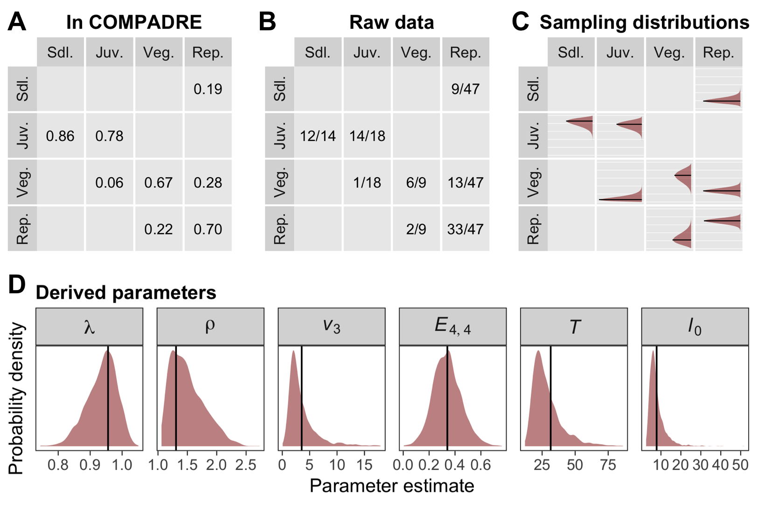
Fig. 1. Illustration of the derivation of sampling distributions for transition rates and derived parameters from a single matrix population model in COMPADRE (1997-1998 transition for Agrimonia eupatoria population B, from Kiviniemi 2002). The top panels depict the original matrix in point estimate form (A), the raw integer counts behind the point estimates (B), and the resulting sampling distribution for each transition (C). Panel (D) depicts sampling distributions for a variety of parameters derived from the matrix population model, including the equilibrium population growth rate (λ), damping ratio (ρ), reproductive value of the vegetative stage class (v₃), elasticity of λ to the stasis transition of the reproductive stage class (E_{4,4}), generation time (T), and life expectancy (l₀).

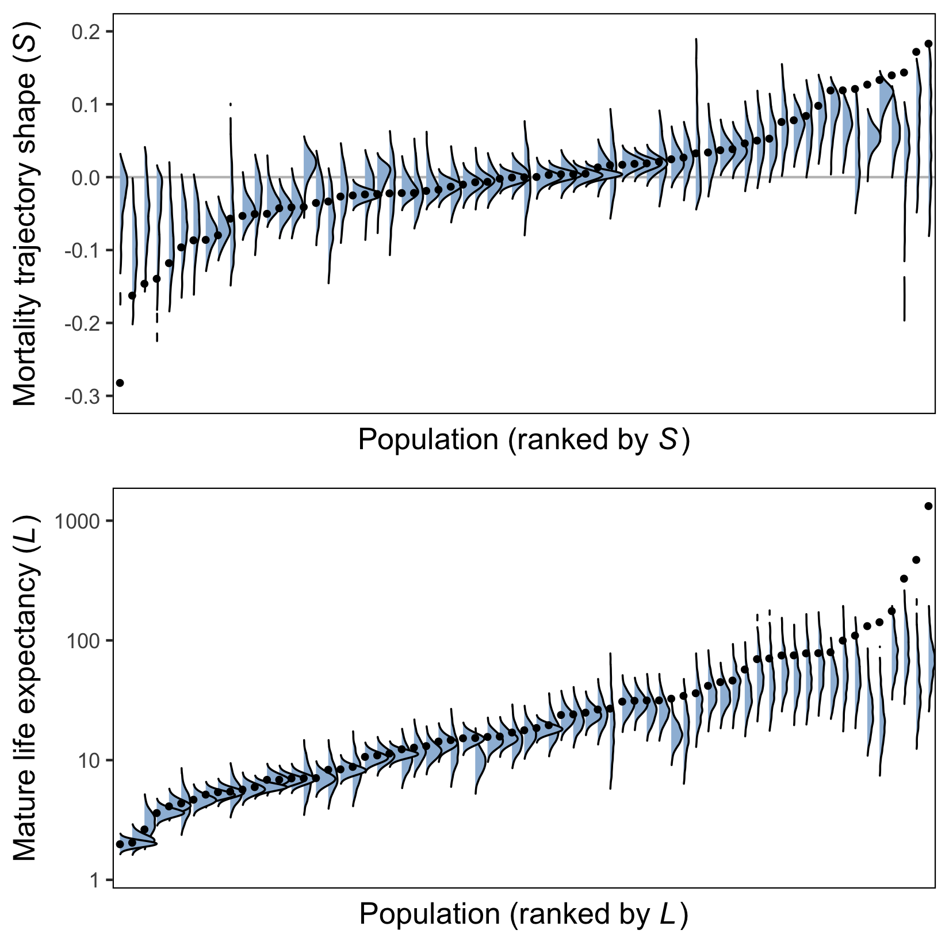
Fig. 2. Point estimates (black dots) and corresponding sampling distributions (blue density kernels) for population-specific estimates of two MPM-derived parameters: the shape of the mortality trajectory (A) and mature life expectancy (B). In each panel, populations are arranged in ascending order according to the point estimate of the relevant parameter.

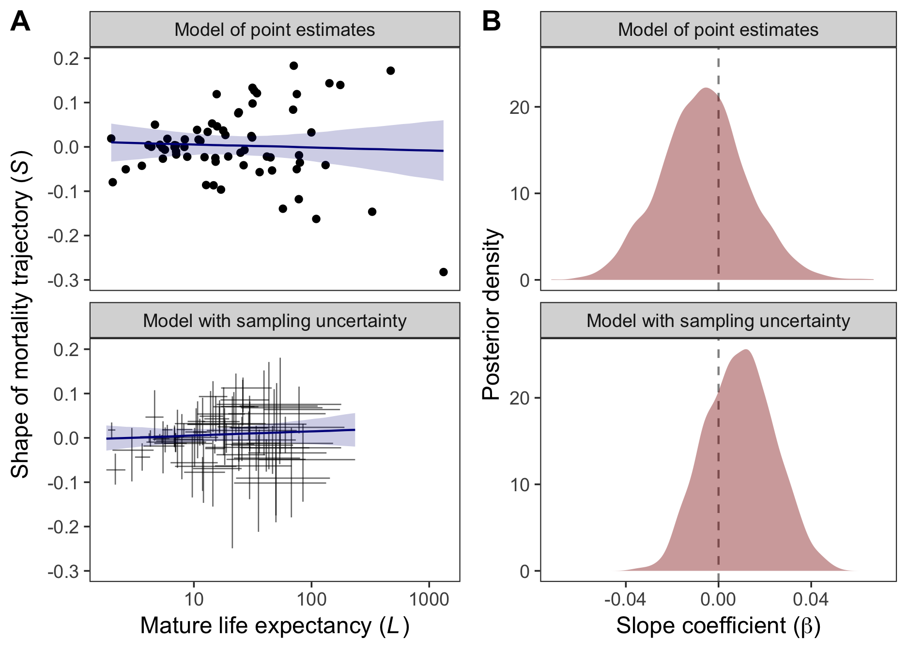
Fig. 3. (A) Relationship between the shape of mortality trajectories and mature life expectancy, based either on point estimates for each variable (top panel) or the underlying sampling distributions (bottom panel). Error bars and ribbons around fit lines represent 95% credible intervals. (B) Posterior distribution for the slope of the relationship between shape and life expectancy (β).

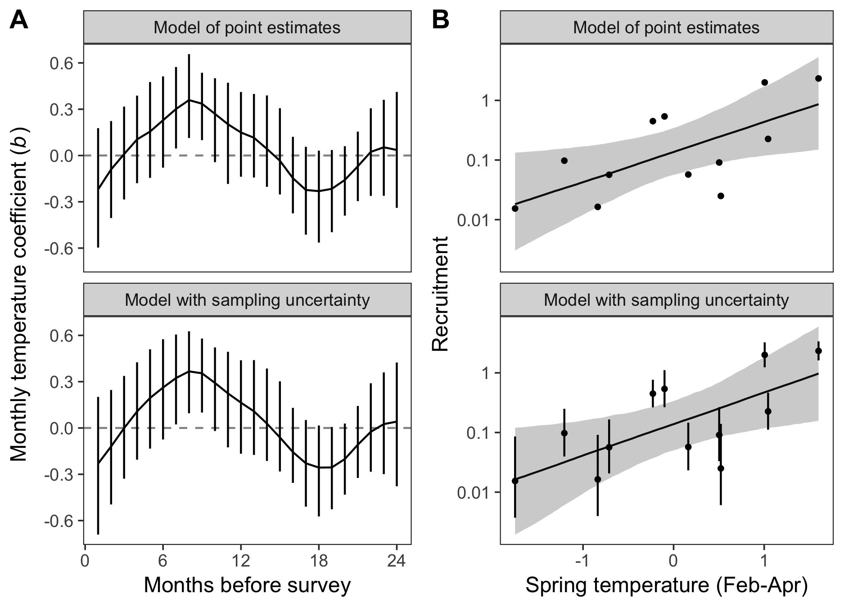
Fig. 4. Results from models relating annual recruitment in Silene spaldingii to deviations in mean temperature, based either on point estimates for recruitment (top row) or the underlying sampling distribution (bottom row). Results in (A) are from a Gaussian process model estimating temperature coefficients for 24 monthly lags, whereas results in (B) are from a simplified model of recruitment versus mean Spring temperature. Error bars and ribbons around fit lines represent 95% credible intervals.

